HA NOI UNIVERSITY OF SCIENCE AND TECHNOLOGY

SCHOOL OF INFORMATION AND COMMUNICATION TECHNOLOGY

*FINAL PROJECT REPORT*

Subject: Car rental company database design

Database Lab

June, 2021

Group 3:

Tô Xuân Hùng – 20194772

Nguyễn Minh Quân – 20194823

Ngô Quốc Thắng – 20194839

Lecturer:

Tran Viet Trung, Ph.D.

Contents

A. Problem statement 4

B. Entity Relational Diagram 5

C. Relational Schema 6

D. Normalizing consideration 7

E. Create users 9

F. Sample data 10

I. Manufacturers: 10

II. Models: 10

III. Countries: 10

IV. Cars: 11

V. Stores: 12

VI. Cities: 12

VII. Customers: 13

VIII.Staff: 13

IX. Addresses: 14

X. Rental: 15

XI. Payments: 16

# Problem statement

A car rental company wants to develop database to archive and manage their chain of stores internationally as following:

* For each customer we keep track of a unique CustomerID, first name, last name, date of birth, phone number, driving license, email.
* For each address we keep track of a unique AddressID, district, postal code.
* For each city we keep track of a unique CityID, city name.
* For each country we keep track of a unique CountryID, country name.
* For each store we keep track of a unique StoreID, phone number.
* For each car we keep track of a unique CarID, registration number, license plate number, rating, car name.
* For each model we keep track of a unique ModelID, model name.
* For each manufaturer we keep track of a unique ManufaturerID, manufaturer name.
* For each staff we keep track of a unique StaffID, first name, last name, salary, email.

Requirements:

* Each customer lives at one address; an address can only accept one customer as resident.
* Each address belongs to one city; but each city can has many addresses.
* Each city belongs to one country; but each country has many cities
* Each customer pays for service at many stores; a store provides service to many customers. Every time a customer makes a payment, we keep track of the payment type (cash or VISA) and payment date.
* Each customer can rent many cars as long as they have returned their previous car; a car can be rented by many customers but in different time . Each time a customer rent a car, we keep track of rental date, return date and rental cost. Rental cost can be calculated by taking the product of cost per hour and (return date minus rental date) times 24.
* Each store can be located in one city; but a city can have many stores.
* Each store can employ many staff; but an employee can only work in one store.
* Each store stocks many cars; but a car can only belong to one store.
* Each car is categorized as one model; a model can have many cars;
* Each manufacturer has many car models; one model can only be manufactured by a manufacturer.

# Entity Relational Diagram

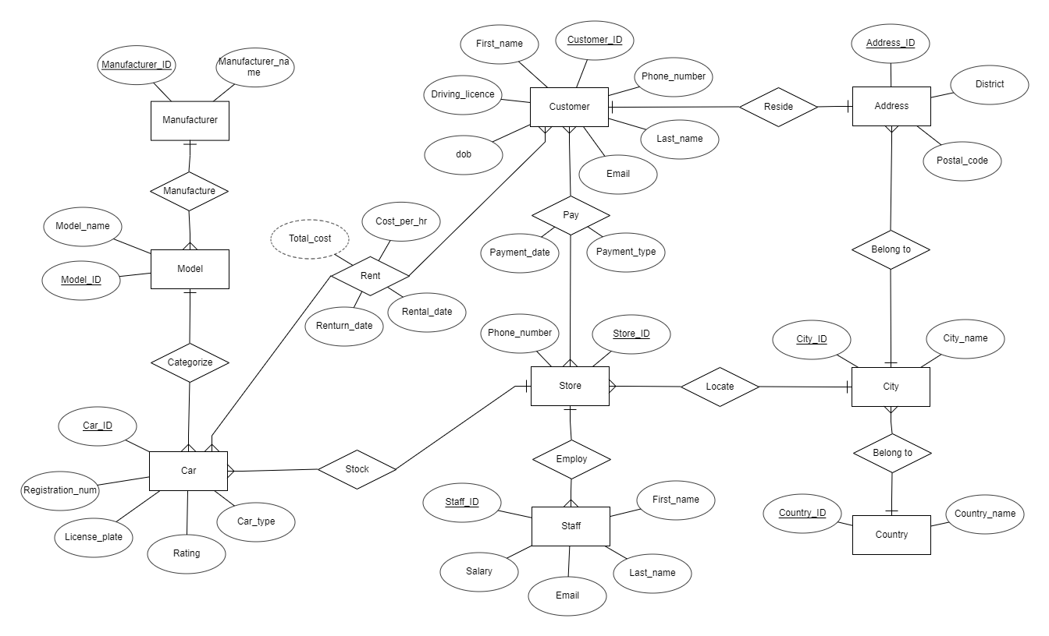

# Relational Schema

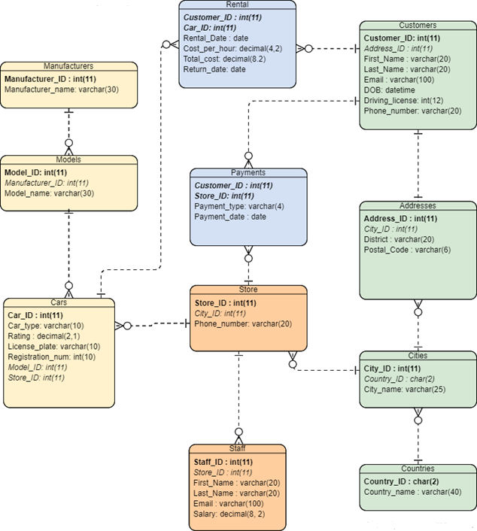

# Normalizing consideration

1. Manufacturers(**Manufacturer_ID**, Manufacturer_name)

R1 = Manufacturers(A, B)

* F = {A → B}
* Minimal cover: G{A → B}
* Minimal key: K{A} → R1(AB)
* Thus, 3NF: Since K is a subset of R1, D = {R1}

1. Models(**Model_ID**, Manufacturer_ID, Model_name)

R2 = Models(A, B, C)

* F = {A → BC}
* Minimal cover: G = {A → BC}
* Minimal key: K = A → R2(ABC)
* Thus, 3NF: Since K is a subset of R2 , D = {R2}

1. Cars(**Car_ID**, Car_type, Rating, License_plate, Registration_num, Model_ID*,* Store_ID)

R3 = Cars(A, B, C, D, E, G, H)

* F = {A → B, A → C, A → D, A → E, A → G, A → H}
* Minimal cover: G = {A→ BCDEGH}
* Minimal key: K = A → R3(ABCDEGH)
* Thus, 3NF: Since K is a subset of R3, D = {R3}

1. Countries(**Country_ID,** Country_name)

R4 = Countries(A, B)

* F = {A→ B}
* Minimal cover: G = {A → B}
* Minimal key: K = A → R4(AB)
* Thus, 3NF: Since K is a subset of R4, D = {R4}

1. Cities(**City_ID**, City_name, Country_ID)

R5 = Cities(A, B, *C*)

* F = {A → B, A → C}
* Minimal cover: G = {A → BC}
* Minimal key : K = A → R5(ABC)
* Thus, 3NF: Since K is a subset of R5, D = {R5}

1. Customers(**Customer_ID**, Address_ID, First_Name, Last_Name, Email, DOB, Driving_license, Phone_number)

R6 = Customers(A, B, C, D, E, G, H, I)

* F = {A → B, A → C, A → D, A → E, A → G, A → H, A → I}
* Minimal cover: G = {A → BCDEGHI}
* Minimal key: K = A → R6(ABCDEGHI)
* Thus, 3NF: Since K is a subset of R6, D = {R6}

1. Stores(**Store_ID**, City_ID, Phone_number)

R7 = Stores(A, B, C)

* F = {A → B, A → C}
* Minimal cover: G = {A → BC}
* Minimal key: K = A → R7(ABC)
* Thus, 3NF: Since K is a subset of R7, D = {R7}

1. Staff(Staff_ID, Store_ID, First_name, Last_name, Email, Salary)

R8 = Staff(A, B, C, D, E, G)

* F = {A → B, A → C, A → D, A → E, A → G}
* Minimal cover: G = {A → BCDEG}
* Minimal key: K = A → R8(ABCDEG)
* Thus, 3NF: Since K is a subset of R8, D = {R8}

1. Addresses(Address_ID, City_ID, District, Postal_Code)

R9 = Addresses{A, B, C, D}

* F = {A → B, A → C, A → D}
* Minimal cover: G = {A → BCD}
* Minimal key: K = A → R9(ABCD)
* Thus, 3NF: Since K is a subset of R9, D = {R9}

10. Rental(***Customer_ID****,* ***Car_ID***, Rental_Date, Cost_per_hour, Total_cost, Return_date)

Because no attribute in this table is multivalued attribute, composite attribute. Beside that, the primary key is not a single column.

* This table is not in 2NF or 3NF but in 1NF.

11. Payments(***Customer_ID, Store_ID***, Payment_type, Payment_date)

Because no attribute in this table is multivalued attribute, composite attribute. Beside that, the primary key is not a single column.

* This table is not in 2NF or 3NF but in 1NF.

# Create users

CREATE USER thangngoquoc IDENTIFIED BY "thangngoquoc";

CREATE USER hungtoxuan IDENTIFIED BY "hungtoxuan";

CREATE USER quannguyenminh IDENTIFIED BY "quannguyenminh";

GRANT ALL ON car_rental.* TO 'thangngoquoc'@'%';

GRANT ALL ON car_rental.* TO 'hungtoxuan'@'%';

GRANT ALL ON car_rental.* TO 'quannguyenminh'@'%';

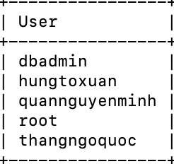

# Sample data

## Manufacturers:

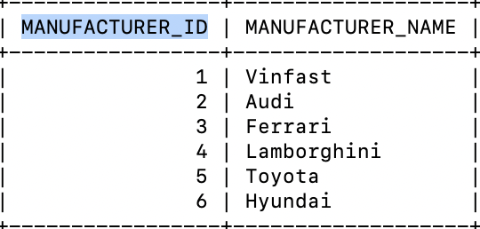

## Models:

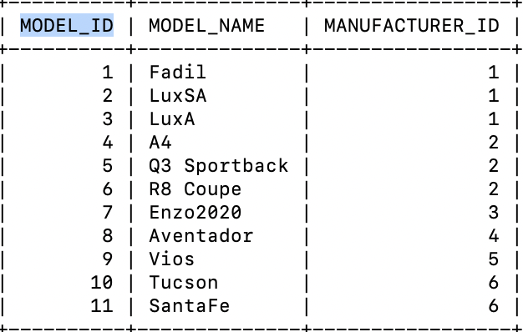

## Countries:

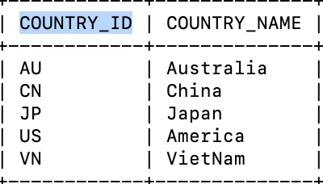

## Cars:

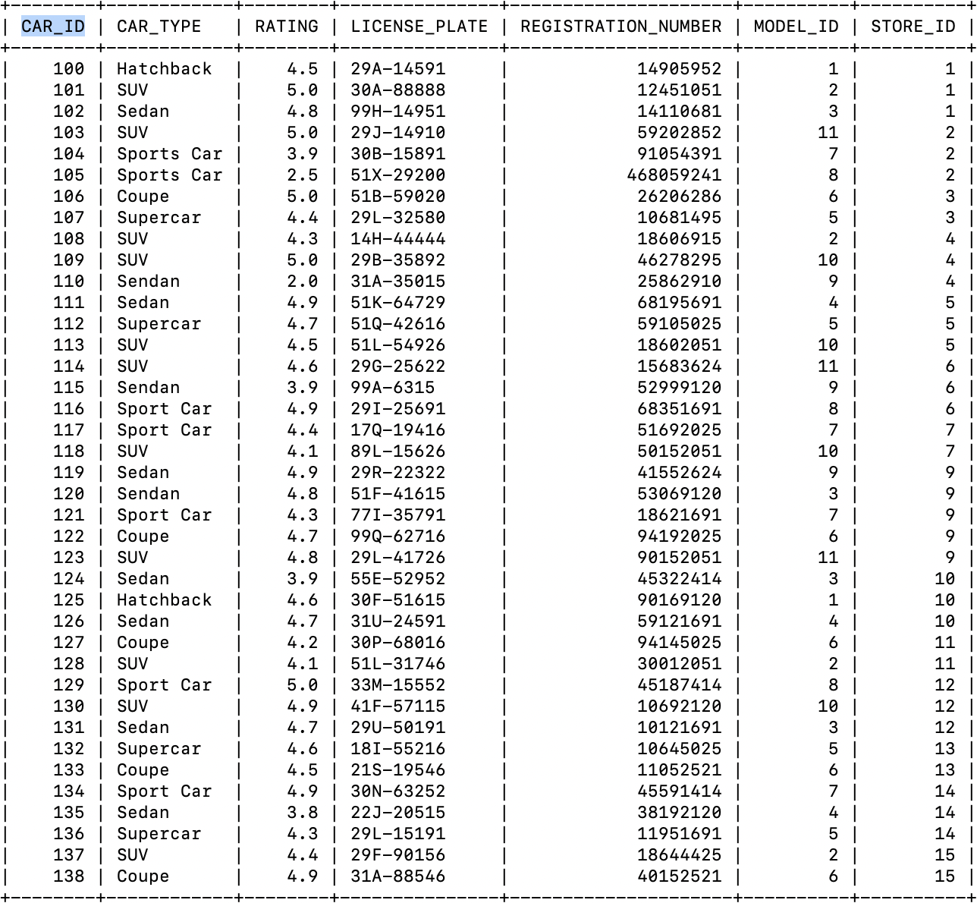

## Stores:

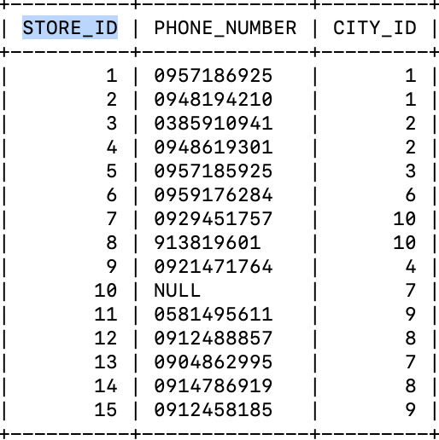

## Cities:

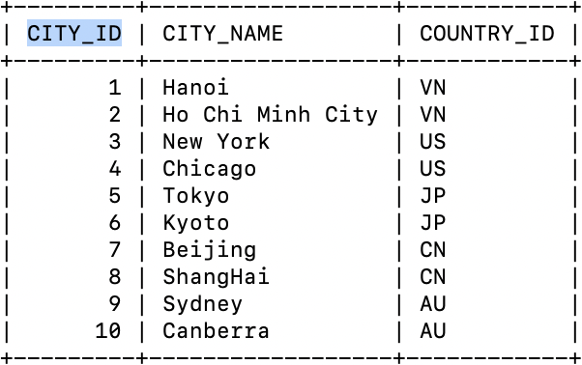

## Customers:

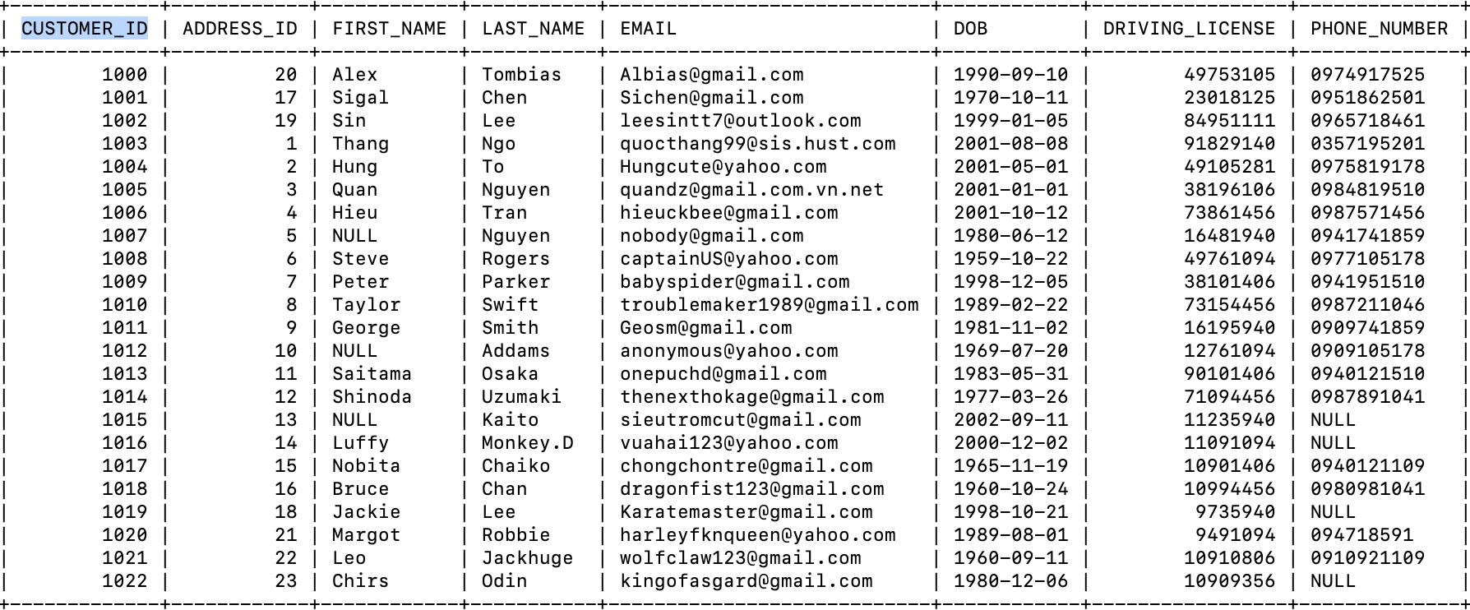

## Staff:

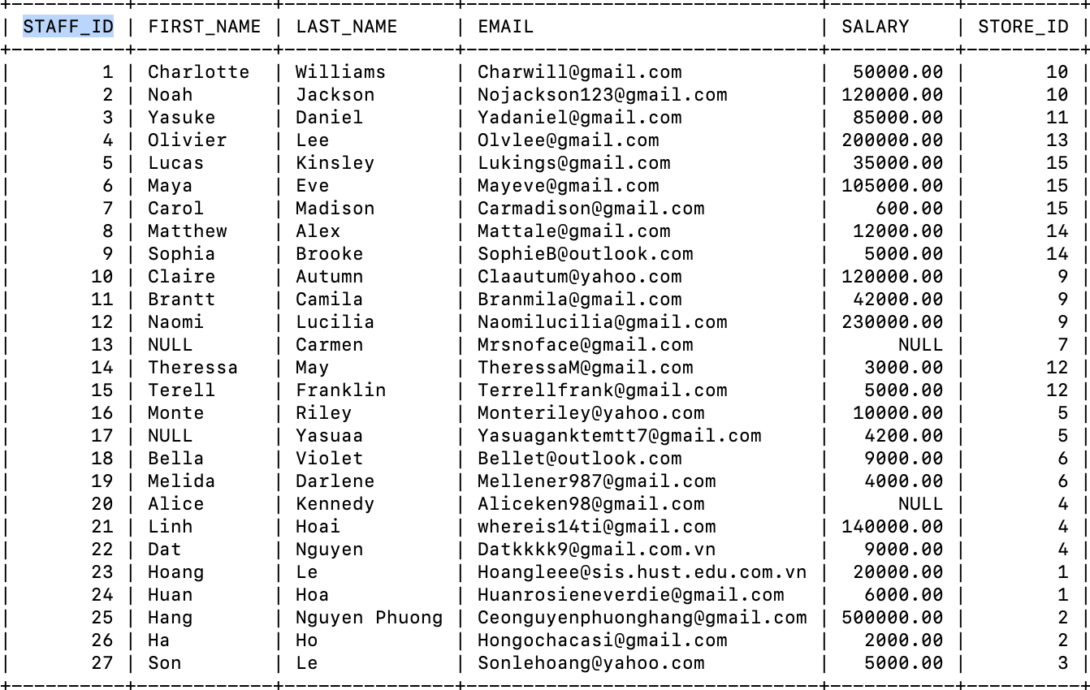

## Addresses:

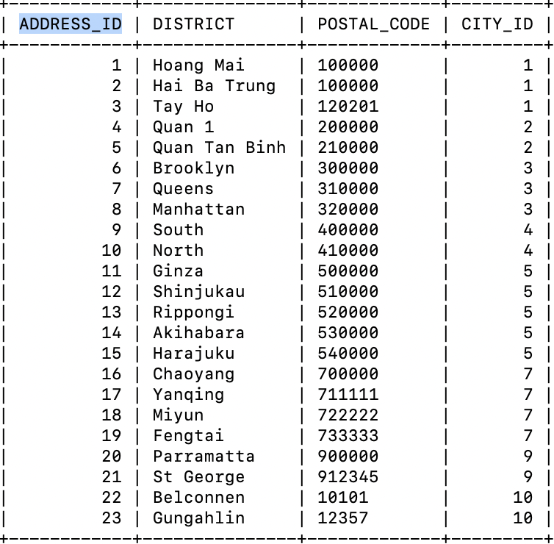

## Rental:

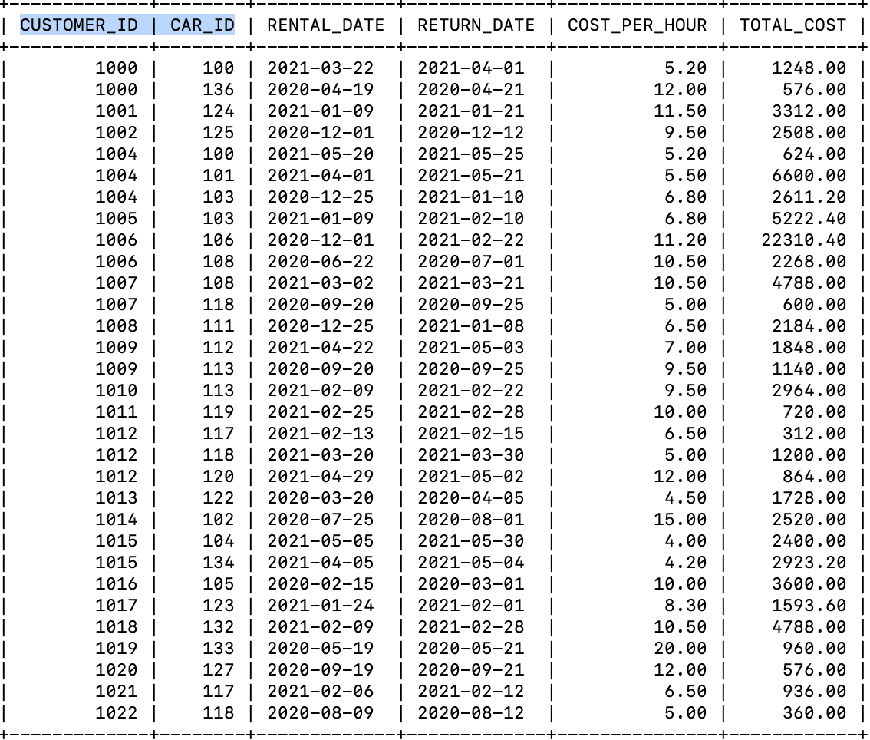

## Payments:

